**TITLE: AUTOMATED GUIDED ROBOT**

Introduction:

One of the most important aspects of automated guided systems is the handling of material flows in industrial or official environments. The system may be complex, in fact inflexible. Using advances in modern autonomous vehicles and multi robot methodology a decentralized system with multiple free navigating systems may be deployed. Such a system can enable truly flexible material handling.

Robots are smart machines that can be programmed and work without human intervention during the travel time, manufacturing processes medical fields etc. The robots perform hard, dangerous work in order to make our life easy as they can work for hours without taking rest. The basic function of AGV are divided into two systems namely navigation and load transfer.

Summary:

For CSE331 project we built a fully automated guided robot. It’s an autonomous car which follows a visual line embedded on the floor or ceiling (usually, a black line on a white surface). The car will transfer weights along this visual line. The user has to do all the loading and unloading. The car will start driving once its switch is turned on, carry the weights through a desired path and stop after it will reach its destination. The car can carry up to ___ kg and It will alert the user if its maximum weight carrying capacity is reached. If the user gives more weights than the car can carry, it won’t start even after the switch is turned on.

For our project we’ve used the following important hardware components:

1. Arduino Uno
2. AD620
3. L293D IC
4. Load Cell
5. IR Sensors

Sensors:

**IR Sensor:**

We have used IR Sensor Module as the line detecting sensor for the project. For line detection logic, we used two preassembled IR Sensors, which consists of IR LED and Photodiode. They are placed in a reflective way so that whenever they come in to proximity of a reflective surface, the light emitted by IR LED will be detected by Photo diode.

The following image shows the working of a typical IR Sensor (IR LED – Photodiode pair) in front of a light colored surface and a black surface.

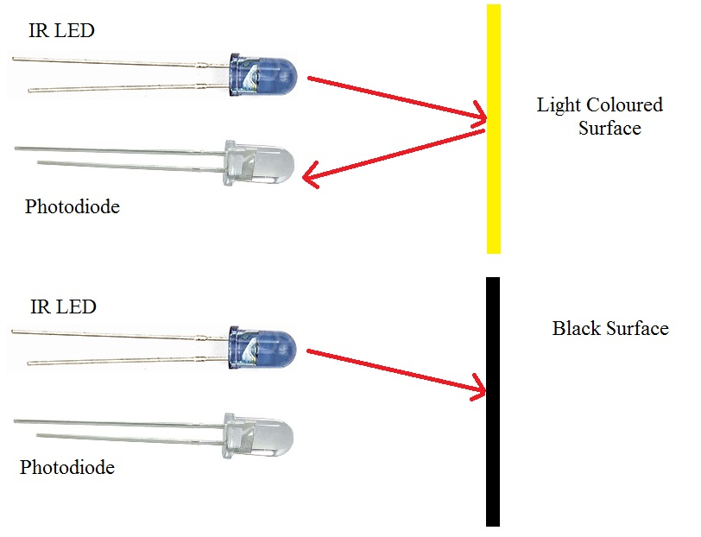

As the reflectance of the light colored surface is high, the infrared light emitted by IR LED will be maximum reflected and will be detected by the Photodiode. In case of black surface, which has a low reflectance, the light gets completely absorbed by the black surface and doesn’t reach the photodiode. We will setup the IR Sensors on the Line Follower Robot such that the two IR Sensors are on the either side of the black line on the floor. When the robot moves forward, both the sensors wait for the line to be detected. Arduino UNO continuously monitors the data from both the sensors and turns the robot as per the line detected by them.

**Load Cell:**

The Load Cell we used is a strain gage type of tension/compression sensor. The strain gauge measures the deformation as a change in electrical resistance. Strain gauge force sensors convert the load acting on them into electrical signals. The gauges themselves are bonded onto a beam or structural member that deforms when weight is applied. In most cases, four strain gauges are used to obtain maximum sensitivity and temperature compensation.  They are configured in a Wheatstone Bridge configuration with four separate resistors connected in bridge network. An excitation voltage - usually 10V is applied to one set of corners and the voltage difference is measured between the other two corners. At equilibrium with no applied load, the voltage output is zero or very close to zero when the four resistors are closely matched in value.

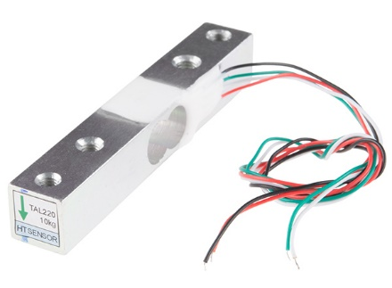

Integrated System:

1. **Motor Driver:**

Our first step was to build the car. For that we used L293D motor driver IC which is the main component of our car. The L293D Motor drivers are capable to drive motors which requires an input voltage up to 36V. It receives signals from Arduino based on the information from the IR Sensors

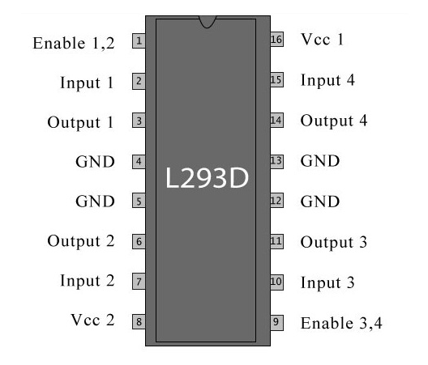L293D is a 16 pin IC. Pins 1 and 9 are enable pins. They are connected to Vcc. Pins 2 and 7 are control inputs from microcontroller for first motor. They are connected to pins 9 and 8 of Arduino respectively. Similarly, pins 10 and 15 are control inputs from microcontroller for second motor. They are connected to pins 4 and 3 of Arduino. Pins 4, 5, 12 and 13 of L293D are ground pins and are connected to Gnd. The motor for left wheel is connected across the pins 3 and 6 of L293D. The other is connected to 11 and 14 pins of L293D. The 16th pin of L293D is Vcc1. This is connected to 5V Vcc. The 8th pins is Vcc2. This is the motor supply voltage. This can be connected anywhere between 4.7V and 36V. In this project, pin 8 if L293D is connected to 9V supply.

1. **Line Follower:**

The Line Follower Robot we have built is Arduino based. Arduino UNO is the main controller in our project. It takes data from the IR Sensors and it gives corresponding signals to the Motor Driver IC. The connection between Aurdino Uno and IR sensors are shown in the following diagram

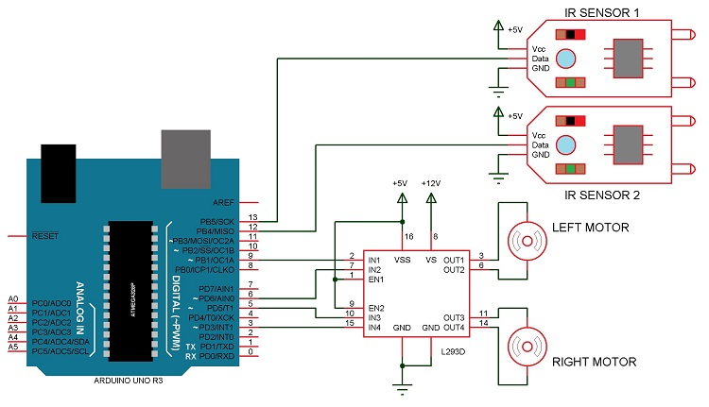

1. **Weight Machine:**

Building a weight machine using only the load cell is not enough. An AD620 instrumental amplifier is generally used with a load cell because its output frequency is too low. The most common color assignment is red for V+, black for V−, green for In+, and white for In−. We used anther Arduino uno for this part. The connection is shown below

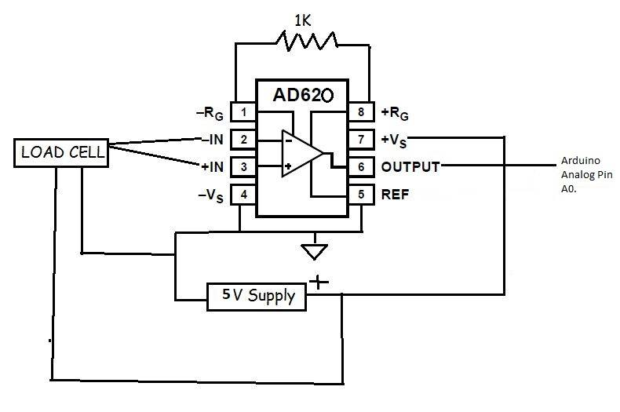

**Conclusion:**

After completing each of these step individually, we combined all of them together to complete our automated car.